Project Testing Phase

1. Introduction
The Testing Phase is carried out to verify that the Script-Controlled ACL works correctly in ServiceNow. The ACL is tested with different users and field values to ensure that authorized users can access the records while unauthorized users are restricted.

2. Objective
- To verify the functionality of the Script-Controlled ACL.
- To ensure access is correctly controlled based on field values.
- To test both authorized and unauthorized access.
- To identify and correct errors in the ACL script or configuration.
- To confirm that the system meets the specified access-control requirements.

3. Activities Performed
- Created test records with different field values.
- Tested record access using an authorized user.
- Tested record access using an unauthorized user.
- Verified the ACL script condition.
- Checked whether the correct records were displayed or restricted.

4. Expected / Produced Output
- ACL access conditions work correctly.
- Authorized users can access permitted records.
- Unauthorized users are prevented from accessing restricted records.
- Field-value-based restrictions function as expected.
- ACL script errors are identified and resolved.
- Final testing confirms the successful operation of the Script-Controlled ACL.

Screenshoot

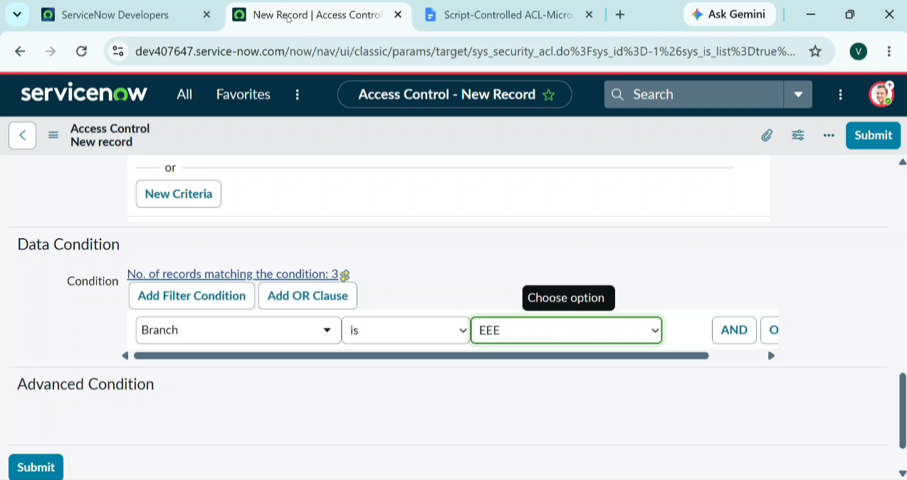

5. Data Flow Diagram
